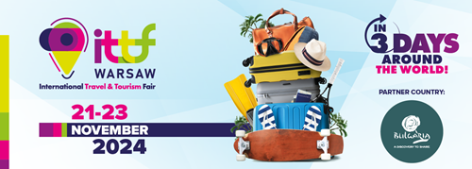

**ITTF International Travel & Tourism Fair - the entire tourism industry in the heart of Warsaw**

On November 21-23, 2024, the Palace of Culture and Science will host the 2nd edition of the **ITTF Wasaw International Travel & Tourism Fair**. This unique event is organized by the MTP Group, the leader of the trade fair market, in cooperation with the Polish Chamber of Tourism, the largest and oldest economic self-government of the tourism industry in Poland.

The fair is accompanied by the motto: “In 3 days around the world”, which perfectly reflects the idea of the fair, which presents the diversity and richness of tourism of the entire globe.

Participation in the event has been announced by the largest travel agencies, including Itaka, Rainbow, Coral Travel and Sun & Fun The presence was also confirmed by countries popular among tourists, including Türkiye, Greece, Bulgaria, Croatia, Tunisia, Slovakia, Malaysia, Moldova, Malta and Cuba. Polish regions will also promote their tourist values, including Małopolska, Mazovia and the Lublin region. There will also be stands of leading carriers, including LOT Polish Airlines, the charter flight consolidator Globe Travel Services and the Stena Line ferry line.

**Bulgaria has become the partner country of the second edition of the ITTF Warsaw International Travel & Tourism Fair.**

The first two days of the fair (Thursday, Friday) will focus on industry talks, conferences, presentations and training. A new feature of this year's edition will be a program for making business appointments via a mobile app, which will allow participants to manage their time more efficiently and estabilish new contacts.

The third day (Saturday), will be a day open to the general public. That day famous bloggers, vloggers and travelers will appear and share their experiences and inspirations from travel.

All entities related to the tourism industry are invited to participate in the fair, especially industry institutions and organizations, embassies and government authorities, local governments, tour operators and travel agents, airlines, guides, accommodation base managers, companies organizing team-building trips, resorts, wellness and spa centers, travel and hotel schools, publishing houses and companies offering new technologies in tourism.

It's worth adding this event to your calendar, which provides an excellent opportunity to make contacts, conduct business talks and promote tourism as a leisure activity. This is the perfect time to discover the tourism assets of specific destinations, regions and countries participating in this unique event!

**Detailed information at: ittfwarsaw.pl**

**We cordially invite business partners and travel enthusiasts to the ITTF Warsaw International Travel & Tourism Fair, November 21-23, 2024, Palace of Culture and Science in Warsaw.**

ITTF Warsaw trade fair team